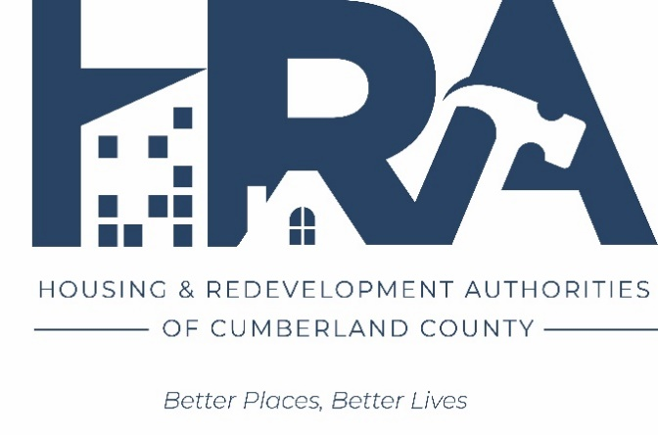

COMMUNITY DEVELOPMENT
BLOCK GRANT (CDBG)
APPLICATION

CUMBERLAND COUNTY PY 2023 CDBG PROGRAM

Date of Application: ____________________
APPLICANT INFORMATION

Applicant Name: __________________________________________________________________

Mailing Address: __________________________________________________________________

_________________________________________________________________

Type of Organization: _____ municipal government

_____ private non-profit - 501(c)(3) or 501(c)(4)

_____ private for-profit

_____ other

Applicant’s Chief Executive Officer: __________________________________________________

Staff Contact Person/Title: __________________________________________________________

Telephone: ________________________ Email: ______________________________________

Applicant’s Fiscal Year: from ______________ to ______________

Applicant’s Federal Employer Identification Number (FEIN): _____________________________

Applicant’s DUNS Number: ________________________________________________________

PROJECT INFORMATION

Project Name: ____________________________________________________________________

Project Site/Location: ______________________________________________________________

Is the project continuation of earlier project? ___ Yes ___No

Is the project part of phased improvements? ___Yes ___ No

Is the project a continuation of a project currently supported with CDBG funds? ____ Yes ____ No

Anticipated project start date is ______________________________________________________
Anticipated completion date is _______________________________________________________

Does this activity address the needs identified in the County’s Consolidated Plan? ___ Yes ___ No

What is the main urgency of this activity? ________________________________________________________________________________ ________________________________________________________________________________ ________________________________________________________________________________

Type of Project: _____ acquisition of property
_____ rehabilitation of housing units (single-family)
_____ rehabilitation of housing units (multi-family)
_____ construction of housing units
_____ public facility (such as a community center, recreational facility, streets, streetscape, curbs and sidewalks, sewer and storm
water systems)
_____ public service (such as counseling, service coordination, crime
prevention, recreation programs and training programs)
_____ economic development, direct assistance to a for-profit entity
(Loans and grants to businesses for acquisition, renovations
and rehabilitation, equipment and working capital)
_____ removal of architectural barriers (such as curb cuts, ramps,
and accessibility improvements)
_____ removal of a blighting influence (rehabilitation, demolition, clearance)
_____ code enforcement in an LMI Revitalization Area

Which of the following national objectives is the proposed project intended to achieve?
_____ benefit principally low-income and moderate-income (LMI) persons
_____ prevent or eliminate a condition of slum or blight
_____ Meet community needs having a particular urgency

If the national objective is to benefit principally LMI persons, how will LMI status be determined in order to meet that objective?
_____ area-wide project (51% or more of residents of the designated
service area is LMI (51% established by census data or survey)
_____ service or benefit will be limited to those who are required to
document that they are LMI
_____ service or benefit will be limited to those who are in a class of
persons who are presumed to be LMI (disabled adults, elderly,
homeless, abused children, battered spouses, etc.)
_____ service is of such a nature and in such a location that it may be
reasonably presumed that beneficiaries will be primarily LMI persons

Amount of Funding Requested on this Application:

a. Amount of CDBG funds requested $_____________

b. Amount of previous CDBG funds received $_____________

c. Amount of applicant contribution $_____________

d. List of other sources of funds ____________________________ $_____________ ____________________________ $_____________
____________________________ $_____________

e. Total estimated project cost $_____________

Note: a+b+c+d must equal e

PROJECT NARRATIVE

Attach a narrative of one to three pages that addresses the following points.

REQUIRED IN ALL APPLICATIONS
____ Why the county funding is necessary
____ Attach a project budget
____ The timetable to complete the project base this schedule on September 1, 2023, award date. NOTE: Project must be completed within 18 months! (May be earlier depending on HUD budget approval).
____ The housing or other community development unmet critical need that the proposed project addresses
____ Describe the problem or need for the project and how the project addresses one of needs identified in the Consolidated Plan
____ How the project will have an identifiable and measurable impact on the need; include a description of the anticipated outcomes
____ A map that locates the activities’ locations, as well as any pictures of structures that funding would be going towards.

Any false statement made knowingly and willfully may subject the signer to penalties under Section 1001 of Title 18 of the United State Code

Name of Authorized Official _____________________________________________________

Title ________________________________________________________________________

__________________________________________ ______________________________ Signature of Authorized Date

INCLUDE AS APPLICABLE:

- If the project is to benefit LMI persons, explain if it will be a direct benefit to persons or families, or will it benefit an area where LMI persons/families reside? If a direct benefit, state the types and numbers of LMI persons you expect will be served by the project during the next year and the procedures to be used to verify and record LMI status of clients and the services provided to them. If the project will benefit an LMI area, describe the service area, and explain how you determined the area.

- If the project is intended to address slum or blight, describe the condition to be corrected and the method to be used (repair, demolition). Attach pictures.

- If the proposal is for an economic development project, state how many jobs will be created, and show how you will make them available to LMI persons; provide a pro forma.

- If the project is a housing rehabilitation project, fully describe the proposed program including the type of properties to be rehabilitated (owner-occupied, rental, vacant-for-resale), whether it is a grant or loan program, the terms of sale or and of repayment or of forgiveness loans and any proposed subsidies to buyers.

- If the project is for property acquisition or new construction, state the final use of property. Provide evidence of due diligence and site control or plans for the same.

- If the project is a public service, furnish proof that the project is a new service or a quantifiable increase of an existing service.

- If the project is code enforcement, provide information on the area experiencing deterioration and on the other improvement activities to be undertaken in the area in conjunction with the code enforcement.

- Provide available maps, drawings, sketches, plans, studies, photos, surveys, etc., as available that will show the location and scope of the proposed project and demonstrate the feasibility of the project.

