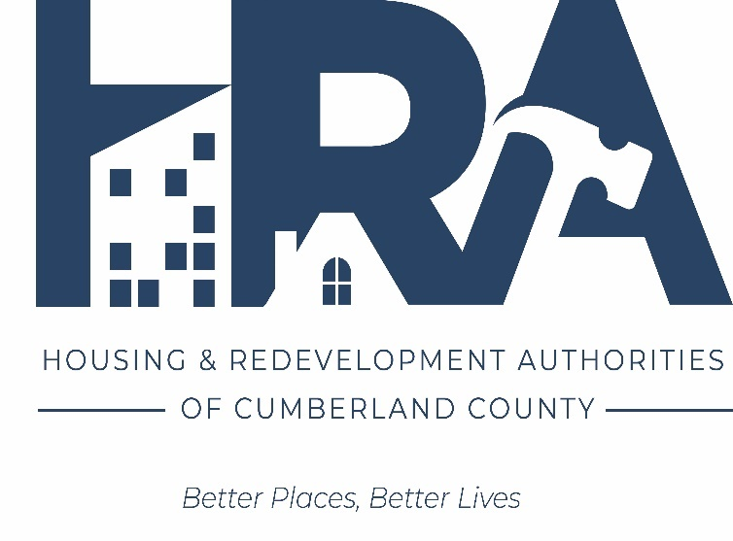

CUMBERLAND STREETVIEW

COMMERCIAL FACADE IMPROVEMENT
GRANT PROGRAM

GUIDELINES

Originally called the Cumberland County Commercial Facade Improvement Loan Program, this program administered by the Cumberland County Redevelopment Authority was modified and a grant program established with a resolution by the Cumberland County Board of Commissioners in late 2014. Working with the Authority, our municipalities, downtown and historic-preservation interests, business and property owners, as well as drawing on our collective experience working with and improving existing grant and similar initiatives in other communities, the program was revised, redesigned and re-launched in 2015.

Cumberland Streetview better reflects our ongoing mission to showcase and diversify the business mix, improve the overall look and better the property inventory making our downtowns and historic sites the places you choose to live, work, shop, play and visit—your business address. Our goal—to continually improve the building stock, storefronts and other downtown assets…to remedy declining conditions…to renovate with an eye to the future…to preserve our distinctive architecture…and to render the downtowns more attractive to all. A more attractive downtown is more attractive to business, and in Pennsylvania’s fastest-growing county, history lives!

___________________________________________________________________________________________

■ PROGRAM AREA The eligible area includes properties located within a municipalities Business, Historic, or Downtown areas.

■ ELIGIBILITY To be eligible, the following criteria must be met.

- work items must relate to the exterior—the facade—of the building
- the work performed must be clearly visible from a public street or way
- if the property is within a historic district, all work performed must meet the U.S. Secretary of the Interior’s standards for historic preservation and be approved by that municipality’s Historical and Architectural Review Board (HARB) receiving a certificate of appropriateness
- all work performed must meet the requirements for remediating conditions of slum or blight, or address code, health or safety issues
- if a tenant, the work performed must have the consent of the property owner
- the owner of the property, regardless of whether that person is the applicant, must be current with their payment of municipal water and sewer bills, as well as all real estate taxes
- the applicant must provide a minimum 25% cash match for the grant—no sweat equity, in-kind services, labor or other reductions can be taken to minimize the required cash match
- the building must be a commercial or mixed use property

- buildings cannot be for sale, marketed for sale or known to be for sale
note: Federal prevailing wages will apply to the entire project. The wage decision must be
included with all bids and proposals.

■ ELIGIBLE WORK ITEMS Eligible work items include but are not limited to the following. Although use of original materials is preferred, other materials are often deemed acceptable and approved by the HARB.

- installation or improvement of gutters and downspouts
- facade washing or brick cleaning including paint removal (chemical processes only)
- repair, replacement and repointing of brick and masonry
- repainting of brick, masonry and wood including window frames and other features
- repair, restoration, renovation and/or replacement of wood
- repair, restoration, renovation, replacement or installation of appropriate handrails and porch balusters
- repair, restoration, renovation, replacement or installation of appropriate decorative or ornamental millwork, dentil work or other architectural details
- repair, restoration, renovation, replacement or installation of exterior lighting
- repair, replacement or installation of shutters
- repair, restoration, renovation and/or replacement of windows and doors
- repair, restoration or replacement of roof (if clearly visible from the public way)
- repair, restoration, renovation or replacement of hardware or hardware accessories such as for windows, doors, shutters or signs
- repair, restoration, renovation or replacement of storefronts
- repair, restoration, renovation or replacement of signage
- repair, restoration, replacement or installation of awnings
- repair or repainting of architectural metals
- stabilization or repair of structural deficiencies
- restoration of historic markers
- removal of historically-inappropriate materials
- preservation, restoration, repair or replacement of distinctive architectural ornamentation including cast and wrought ironwork and stained glass

■ GRANT TERMS The maximum grant is $12,000. The maximum grant awarded shall be no more
than 75% of the eligible project costs for repairs or improvements. The applicant is required to provide a
minimum 25% cash match. Grants exceeding $12,000 may be available at the discretion of the Redevelopment
Authority.

Once approved, the applicant shall sign a grant agreement with the Cumberland County Redevelopment Authority (Authority)—who administers the program—requiring that the grant recipient do the following.

  - deposit their 25% share of the property improvement cost with the Authority prior to the start
of work

  - agree to allow the Authority to make payments to the contractor for all work completed

  - agree to comply with Title VI of the Civil Rights Act of 1964 and regulations issued
pursuant thereto (24 CFR Part 1) prohibiting discrimination on the basis of race, color, creed or national origin in the sale, lease, rental, use or occupancy of the subject property

  - agree to comply with Executive Order 11246 and all regulations issued pursuant
thereto (24 CFR Part 130) which provides that no person shall be discriminated against on the basis of race, color, religion, sex or national origin in the award of contracts financed with federal funds

  - agree not to award contracts for work under this program to contractors ineligible for
work as determined by the U.S. Department of Housing and Urban Development

  - agree to abide by statutory and regulatory provisions pertaining to the Davis Bacon
Act, Contract Work Hours and Safety Standards Act and Copeland Anti-Kickback Act including wage rates

■ PROGRAM PROCEDURES

- complete an application online and provide a $100, non-refundable check/application fee made payable to the Cumberland County Redevelopment Authority and mail it to:

Cumberland County Redevelopment Authority
ATTN: Sue Dunfee
114 N. Hanover St.
Carlisle PA, 17013

- meet with the Housing Authority’s Housing Rehabilitation Specialist to discuss work to be completed.

- owner will be provided with current Davis Bacon Wage Rates and Job Specifications to obtain a minimum of three quotes for the work to be performed. and select the apparent low bid. The wage decision must be included with all bids and proposals.

note: exceptions may be made to selecting the apparent low bid with the approval of the
Authority

- sign Grant Agreement and provide 25% match to the Housing Authority

- in-progress and final payments shall be made by the Authority upon receipt of invoices and certification by the grantee and Authority that the work has been performed satisfactorily. Authority staff will conduct employee interviews to ensure prevailing wages being paid

■ CONSIDERATIONS USED TO DETERMINE PROJECTS Funding for the program is increasingly limited making decisions as to which projects are most worthy even more difficult. Because of this—and working with the Authority, our municipalities, downtown interests and business and property owners, as well as tapping our experience working with similar programs and charting those results—other considerations will be weighed in addition to the eligibility requirements for each prospective project. These considerations relate to the tremendous incentive offered by the program—for both responsible existing property and business owners as well as new owners or business tenants—and the impact the program can have on the streetview.

CUMBERLAND STREETVIEW …is an incentive for downtown property owners and businesses or
potential property owners and businesses, as well as owners or those operating a business in a historic property
the program…

- prioritizes retailers, restaurants or other downtown assets or properties with such…businesses that characterize a downtown
- links improvements to those noted in the studies and other research…such as for full-view windows, improved lighting and updated awnings that fit the historic setting
- is not a maintenance or “pre-condemnation” program…property and business owners should keep their buildings and storefronts in good repair
- is not for properties or businesses that are for sale…
- …can be offered to new owner or tenants to make the changes they require or would like
- invests in the future…questions whether given the current tenant or owner, other conditions or dynamics, the investment is sound
- weighs the applicant’s investment…is it 25% or more, is it part of a larger project
- makes decisions based on the merits of the project…its impact (see below)

CUMBELRAND STREETVIEW …projects should have an impact on the downtown business community, neighborhood or setting and the overall look
the program…

- assures the visibility of the work completed and improvements…that the “before” and “after” photos look different
- improves the “streetview”…what you see and experience
- targets pronounced, problem, properties where the owner or tenancy has changed…so improvements can be made
- cultivates projects—businesses—in the pipeline…assuring funding for key coming projects
- assures compatibility, harmony and variety…in a historic setting, even modern motifs can exist
- spurs neighboring properties and businesses into action…for improvement along the block
- promotes walkability…with visible improvements, pedestrian-scaled upgrades, and safety additions
- sparks stores outdoors and boosts foot traffic…creating more welcoming storefronts and blocks that are more attractive, appealing and welcoming
- improves perception…by improving safety via a more cared-for environment, better lighting and other features
- ensures a well-conceived application…enables the Authority to offer suggestions, other approaches or preferred options for better outcomes
- addresses the results…specifically, what is included in the project and what it will look like once complete including colors, finishes and products
- considers how the project will be received by the downtown community and public
- serves as a resource for new retailers, restaurants or downtown assets

