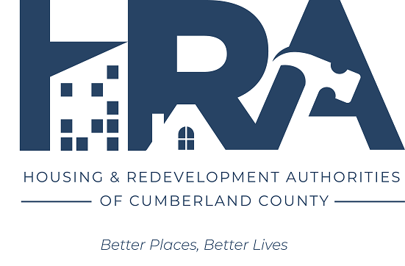
COMMUNITY DEVELOPMENT
BLOCK GRANT (CDBG) PROGRAM
CARLISLE BOROUGH

Plan Year: ____________ Date of Application: ______________

APPLICANT INFORMATION
Applicant Name: ____________________________________________________________________
Mailing Address: ____________________________________________________________________
Type of Organization:
________ Municipal Government
________ Private Non-Profit - 501(c)(3) or 501(c)(4)
________ Private For-Profit
________ Community Housing Development Corporation (CHDO)
________ Other
Applicant’s Chief Executive Officer: ___________________________________________________
Staff Contact Name and Title: ________________________________________________________
Telephone: ____________________________ Email: _____________________________________
Applicant’s Fiscal Year: ______________ Applicant’s UEI Number: _______________________
Applicant’s Federal Employer Identification Number: ___________________________________

PROJECT INFORMATION
Project Name: ______________________________________________________________________
Project Location: ____________________________________________________________________
Type of Project:
________ Acquisition of Property
________ Rehabilitation of Housing Units (Single-Family)
________ Rehabilitation of Housing Units (Multi-Family)
________ Construction of Housing Units
________ Public Facility (such as community center, recreational facility, streets, streetscape, curbs and sidewalks, water, sewer, and storm water systems)
________ Public Service (such as counseling, service coordination, crime prevention, recreational programs, and training programs)
________ Economic Development, Direct Assistance to a For-Profit Entity (such as loans and grants to businesses for acquisition, renovations and rehabilitation, equipment and working capital)
________ Removal of Architectural Barriers (such as curb cuts, ramps, and accessibility improvements)
________ Removal of a Blighting Influence (such as rehabilitation, demolition, or clearance)
________ Code Enforcement in an LMI Revitalization Area
Which of the following national objectives is the proposed project intended to achieve?
________ Benefit principally low-to-moderate income (LMI) persons
________ Prevent or eliminate a condition of slum or blight
If the national objective is to benefit principally LMI persons, how will LMI status be determined in order to meet that objective?
________ Area-Wide Project (51% or more of residents of the designated service area are LMI as established by census data or survey)
________ Service or benefit will be limited to those who are required to document that they are LMI
________ Service or benefit will be limited to those who are in a class of persons who are presumed to be LMI (disabled adults, elderly, homeless, abused children, battered spouses, etc.)
________ Service is of such a nature and in such a location that it may be reasonably presumed that beneficiaries will be primarily LMI persons
Is the proposed project a continuation of a project currently supported with CDBG funds?
________ Yes ________ No
The anticipated project start date is ____________ and the completion date is ____________

Amount of funding requested on this application:
Personnel Costs: __________________
Non-Personnel Costs: _________________
Total Amount Requested: __________________
Other funds available for this project (please provide source and amount):
1. ________________________________________________
2. ________________________________________________
3. ________________________________________________
4. ________________________________________________
Total project cost (amount requested + other available): _______________________

PROJECT NARRATIVE (attach additional pages as needed)
Please provide a general description of the project activities.

Please describe the unmet critical need this project will address.

Describe the problem or need for the project and how the project addresses one of needs identified in the Consolidated Plan.

Please share how the project will have an identifiable and measurable impact on the need; include a description of the anticipated outcomes.

Return completed application to:

Mikayla Kitchen
Assistant Director of the Redevelopment Authority
114 N Hanover Street
Carlisle, PA 17013

