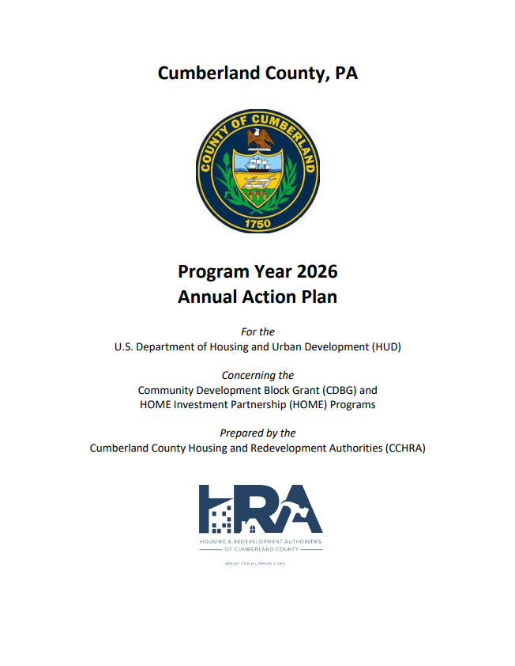

Executive Summary

AP-05 Executive Summary - 24 CFR 91.200(c), 91.220(b)
1. Introduction
Cumberland County is a federal entitlement community under the U.S. Department of Housing and Urban Development’s (HUD) Community Development Block Grant (CDBG) Program and the HOME Investment Partnerships Program (HOME). As a HUD entitlement community, the County is required to prepare a Five-Year Consolidated Plan (CP) in order to implement any federal programs that fund housing, community development and economic development within the community. The Cumberland County CP covers the period from FY 2025 through FY 2029 (July 1, 2025 through June 30, 2029). This CP is for all of the municipalities in Cumberland County with the exception of Carlisle Borough, which prepares its own CP. This CP will be submitted to HUD for approval. The lead entity responsible for the preparation of the CP is the Cumberland County Housing and Redevelopment Authorities (CCHRA). Cumberland County has, through the CP, developed a single, consolidated planning and application document in consultation with public and private agencies. The CP for Cumberland County will serve the following functions: • A planning document that enables the County to view its HUD funding, not in isolation, but as one tool in a comprehensive strategy to address housing, community development, and economic development needs; • An application for CDBG Program funds and HOME Program funds under HUD's formula grant; • A strategy document to be followed in carrying out HUD programs; and • An action plan that provides a basis for assessing performance in the investment of CDBG and HOME funds. Purpose of the Consolidated Plan • To provide decent housing by preserving the affordable housing stock, increasing the availability of affordable housing, reducing discriminatory barriers, increasing the supply of supportive housing for those with special needs, and transitioning homeless persons and families into housing. • To provide a suitable living environment through safer, more livable neighborhoods, greater integration of low- and moderate- income residents throughout the County, increased housing opportunities, and reinvestment in deteriorating communities. • To expand economic opportunities through more jobs paying self-sufficient wages, homeownership opportunities, development activities that promote long-term community viability, and the empowerment of low- and moderate- income persons to achieve selfsufficiency. Cumberland County is expected to receive the following federal resources in FY 2025; estimated projections for five years follow in parentheses: • CDBG: $1,100,000 ($5,000,000) • HOME: $400,000 ($2,000,000)
2. Summarize the objectives and outcomes identified in the Plan
This could be a restatement of items or a table listed elsewhere in the plan or a reference to another location. It may also contain any essential items from the housing and homeless needs assessment, the housing market analysis or the strategic plan.
The Strategic Plan provides a framework to address the needs of the County for the next five years using approximately $6 million in CDBG funds and approximately $2 million in HOME funds. All future activities funded in the next five years will support at least one objective and one outcome. The County’s framework for realizing the objectives and outcomes include the following goals: • Maintain and increase affordable housing • Reduce blight conditions • Improve public facilities • Provide vital public services • Enhance economic opportunities Outcomes show how programs and activities benefit a community or the people served. The outcomes that will illustrate the benefits of each activity funded by the CDBG program are: • Improve availability, accessibility and affordability • Increase homebuyers • Increase decent and livable housing • Improve community sustainability • Increase services for low- and moderate-income (LMI) families • Assist elderly and disabled persons • Decrease homelessness • Provide decent, affordable housing • Provide a suitable living environment • Increase homeownership • End chronic homelessness
3. Evaluation of past performance
This is an evaluation of past performance that helped lead the grantee to choose its goals or projects.
The following evaluation of past performance is from the Program Year (PY) 2022 and 2023 Consolidated Annual Performance and Evaluation (CAPER) reports. The accomplishments that follow are those achieved through the expenditure of CDBG and HOME funds.
4. Summary of Citizen Participation Process and consultation process
Summary from citizen participation section of plan.
CCHRA actively consulted with a variety of non-profits, social service providers, community citizens, and other governmental agencies. This coordination was done in an effort to determine the needs of the County and better allocate entitlement resources. As described in detail in PR-15, the following outreach and hearings included: in-person and telephone stakeholder meetings, focus group meetings, public meetings, a community outreach survey, and a Housing Summit event.
5. Summary of public comments
This could be a brief narrative summary or reference an attached document from the Citizen Participation section of the Con Plan.
No public comments were received.
6. Summary of comments or views not accepted and the reasons for not accepting them
No public comments were received.
7. Summary
See above.

PR-05 Lead & Responsible Agencies – 91.200(b)
1. Agency/entity responsible for preparing/administering the Consolidated Plan
Describe the agency/entity responsible for preparing the Consolidated Plan and those responsible for administration of each grant program and funding source.
Agency Role | Name | Department/Agency

CDBG Administrator | CUMBERLAND COUNTY | Community Development, CCHRA
HOME Administrator | CUMBERLAND COUNTY | Community Development, CCHRA
 |  | Community Development, HRACC
Table 1 – Responsible Agencies

Narrative (optional)
Cumberland County Housing and Redevelopment Authorities (CCHRA) is the lead agency for the preparation of the Five-Year Strategic Plan and administration of the CDBG and HOME programs for the County. Funding requests typically open in June, with applications due at the end of August. Final action is generally provided by the Commissioners in late October/early November before the document is submitted to HUD on November 15th.
Consolidated Plan Public Contact Information
Cumberland County Housing and Redevelopment Authorities 114 North Hanover Street, Carlisle, PA 17013 Contact: Mary Kuna, Executive Director Phone: (717) 249-0789, ext. 118 Email: mkuna@cchra.com Web site: www.cchra.com

AP-10 Consultation – 91.100, 91.200(b), 91.215(l)
1. Introduction
CCHRA developed an outreach effort to maximize input from a large cross-section of stakeholders. This outreach effort, as described in PR-15, included public meetings, published meeting notices and flyers, focus group meetings, and a Housing Summit event. Tables 2 and 3 include the wide variety of entities and agencies that were engaged in the CP’s Outreach Program.
Provide a concise summary of the jurisdiction’s activities to enhance coordination between public and assisted housing providers and private and governmental health, mental health and service agencies (91.215(l))
CCHRA works closely with community providers, including Continuum of Care (CoC) organizations and Safe Harbor, to develop strategies to address homelessness. In addition, CCHRA receives an annual contract from the County Mental Health office to provide Housing Services for Mental Health, Intellectual and Developmental Disabilities (MH.IDD) persons. Services are offered to people of all ages with serious mental illness or intellectual and developmental disabilities. Residents of Cumberland or Perry Counties call either Stevens Center in Carlisle or Penn State Holy Spirit in Camp Hill.
Describe coordination with the Continuum of Care and efforts to address the needs of homeless persons (particularly chronically homeless individuals and families, families with children, veterans, and unaccompanied youth) and persons at risk of homelessness.
Cumberland County actively participates in the Central Valley Regional Homeless Advisory Board (CVRHAB). Planning for assistance for the homeless in Cumberland County is coordinated through the State and locally through participation in a Continuum of Care (CoC). CCHRA works with other community providers, including New Hope Ministries, Hope Station, and Safe Harbor organizations, to develop strategies to address homelessness. CV-RHAB plays a central role in planning and implementing the CoC. The CV-RHAB’s specific roles include the formulation and monitoring of goals and action steps, the identification and analysis of unmet needs, the determination of regional priorities, and the review and ranking of all regional projects submitted under the CoC application process.
Describe consultation with the Continuum(s) of Care that serves the jurisdiction's area in determining how to allocate ESG funds, develop performance standards for and evaluate outcomes of projects and activities assisted by ESG funds, and develop funding, policies and procedures for the operation and administration of HMIS
CCHRA works with community providers, including CV-RHAB, to develop strategies to address homelessness. In addition, the executive director of CCHRA is chair of CV-RHAB and CCHRA has four staff members who work directly on homeless and special needs housing. The RHAB’s specific roles include the formulation and monitoring of goals and action steps, the identification and analysis of unmet needs, the determination of regional priorities, and the review and ranking of all regional projects submitted under the CoC application process. Every two years CCHRA applies for Emergency Solutions Grant (ESG) funds. The primary use for ESG funds is: 1) rapid rehousing initiatives; 2) Essential services for emergency shelters; 3) Street medicine outreach; and 4) homeless prevention measures.
2. Describe Agencies, groups, organizations and others who participated in the process and describe the jurisdiction’s consultations with housing, social service agencies and other entities

Table 2 – Agencies, groups, organizations who participated
1 | Agency/Group/Organization | New Hope Ministries
1 | Agency/Group/Organization Type | Services - Housing  Services-homeless  Services-Education  Services-Employment  Regional organization
1 | What section of the Plan was addressed by Consultation? | Homeless Needs - Families with children  Homelessness Strategy  Anti-poverty Strategy
1 | Briefly describe how the Agency/Group/Organization was consulted. What are the anticipated outcomes of the consultation or areas for improved coordination? | New Hope Ministries is a faith-based social service agency that serves the Cumberland County region by supporting programs that promote family stability.
2 | Agency/Group/Organization | United Way of Carlisle and Cumberland County
2 | Agency/Group/Organization Type | Homeless Advocates
2 | What section of the Plan was addressed by Consultation? | Homeless Needs - Chronically homeless  Homeless Needs - Families with children  Homelessness Needs - Veterans  Homelessness Needs - Unaccompanied youth  Homelessness Strategy  Anti-poverty Strategy
2 | Briefly describe how the Agency/Group/Organization was consulted. What are the anticipated outcomes of the consultation or areas for improved coordination? | In-person interviewKey focus areas revolve around health, educationand financial stability of the residents ofCumberland County
3 | Agency/Group/Organization | Safe Harbour
3 | Agency/Group/Organization Type | Services - Housing  Services-Children  Services-homeless  Services-Health
3 | What section of the Plan was addressed by Consultation? | Homeless Needs - Chronically homeless  Homeless Needs - Families with children  Homelessness Needs - Veterans  Homelessness Needs - Unaccompanied youth  Homelessness Strategy
3 | Briefly describe how the Agency/Group/Organization was consulted. What are the anticipated outcomes of the consultation or areas for improved coordination? | Safe Harbour provides housing and supportiveservices for homeless and nearly homelessindividuals and families to help them achieveindependent living by improving their basic lifeskills for more than three decades.
4 | Agency/Group/Organization | Carlisle Housing Opportunities Corporation
4 | Agency/Group/Organization Type | Housing  Services - Housing
4 | What section of the Plan was addressed by Consultation? | Housing Need Assessment
4 | Briefly describe how the Agency/Group/Organization was consulted. What are the anticipated outcomes of the consultation or areas for improved coordination? | Carlisle Housing Opportunities Corporation takeson properties and rebuilds them to get them backonto the housing market, targeting low-incomefamilies. The corporation aims to allow forfamilies to become homeowners and better helpthem become a part of the community.
5 | Agency/Group/Organization | Central Valley Regional Homeless Advisory Board (CV-RHAB)
5 | Agency/Group/Organization Type | Regional organization
5 | What section of the Plan was addressed by Consultation? | Homelessness Strategy  Anti-poverty Strategy
5 | Briefly describe how the Agency/Group/Organization was consulted. What are the anticipated outcomes of the consultation or areas for improved coordination? | CV-RHAB and the CoC agencies were consultedand participated.
6 | Agency/Group/Organization | CUMBERLAND COUNTY AGING & COMMUNITY SERVICES
6 | Agency/Group/Organization Type | Services-Elderly Persons
6 | What section of the Plan was addressed by Consultation? | Non-Homeless Special Needs
6 | Briefly describe how the Agency/Group/Organization was consulted. What are the anticipated outcomes of the consultation or areas for improved coordination?
7 | Agency/Group/Organization | Cumberland-Perry MH.IDD
7 | Agency/Group/Organization Type | Services-Persons with Disabilities  Regional organization
7 | What section of the Plan was addressed by Consultation? | Non-Homeless Special Needs
7 | Briefly describe how the Agency/Group/Organization was consulted. What are the anticipated outcomes of the consultation or areas for improved coordination?
8 | Agency/Group/Organization | CUMBERLAND VALLEY HABITAT FOR HUMANITY, INC.
8 | Agency/Group/Organization Type | Housing including new and rehab
8 | What section of the Plan was addressed by Consultation? | Housing Need Assessment
8 | Briefly describe how the Agency/Group/Organization was consulted. What are the anticipated outcomes of the consultation or areas for improved coordination?
9 | Agency/Group/Organization | HOPE STATION
9 | Agency/Group/Organization Type | Services-Children  Services-Elderly Persons  Services-Health  Services-Education  Services-Employment
9 | What section of the Plan was addressed by Consultation? | Non-Homeless Special Needs  Anti-poverty Strategy
9 | Briefly describe how the Agency/Group/Organization was consulted. What are the anticipated outcomes of the consultation or areas for improved coordination?
10 | Agency/Group/Organization | Community CARES
10 | Agency/Group/Organization Type | Regional organization  Homeless advocate agency
10 | What section of the Plan was addressed by Consultation? | Anti-poverty Strategy
10 | Briefly describe how the Agency/Group/Organization was consulted. What are the anticipated outcomes of the consultation or areas for improved coordination?

Identify any Agency Types not consulted and provide rationale for not consulting
All relevant agencies were consulted in the process of developing the Consolidated Plan and the Annual Plan.

Other local/regional/state/federal planning efforts considered when preparing the Plan
Name of Plan | Lead Organization | How do the goals of your Strategic Plan overlap with the goals of each plan?
Continuum of Care | CV-RHAB | CV-RHABÃ¿Â¢Ã¿Â¿Ã¿Â¿s strategic plan was reviewed to incorporatethe key sections of the document to addresshomelessness.
Cumberland County Analysis to Fair Housing Choice, | Cumberland County | Identify barriers to fair housing in the County
Pathway to Hope | Salvation Army | Pathway to Hope is an innovative and long-termapproach to providing targeted services to familieswith a desire to take action to break the cycle of crisisand enable a path out of inter-generational poverty.
Table 3 – Other local / regional / federal planning efforts

Narrative (optional)
In accordance with 24 CFR 91.100(4), the County will notify adjacent units of local government of the non-housing community development needs included in its CP. The County also will provide a copy of the approved CP to the Pennsylvania Department of Community and Economic Development. In addition, CCHRA will provide a copy of the CP to the Cumberland County Planning Commission. CCHRA continues to interact with the various public and non-profit institutions that provide housing and supportive services to low-income residents. Although the agencies are independent of one another, they work together to ensure that their programs and services are coordinated and that residents are served.

AP-12 Participation – 91.105, 91.200(c)
1. Summary of citizen participation process/Efforts made to broaden citizen participation
Summarize citizen participation process and how it impacted goal-setting

CCHRA actively consulted with a variety of non-profits, social service providers, community citizens, and other governmental agencies. This coordination was done in an effort to determine the needs of the Borough and better allocate entitlement resources. • Six focus group meetings were held June 25-27, 2024, and July 30, 2024, with affordable/special needs housing providers, business associations, homeless providers, community building organizations, economic development officials, and health and human service providers. • Two Public Meetings, which were open to the general public and advertised, were held on January 15 and February 26, 2025. All public hearings were properly advertised in The Sentinel in accordance with the County’s Citizen Participation Plan. • A Community Outreach Survey was conducted for an 8-month period. • A Housing Summit on September 18, 2024, was held at Dickenson College to educate attendees on the Fair Housing Act and economic and market influences and challenges placed on attainable housing. Valuable Resources: • Review of existing community development-related planning documents, including the Cumberland County Comprehensive Plan (updated in 2025), Housing Summit Summary 2024, PHRA reports, and strategic plans and annual reports from the involved social service groups. Plan Hearings: A Summary of the Plan was placed on file for review by interested parties at the following locations: • CCHRA, 114 N. Hanover Street, Carlisle, PA 17013 • CCHRA website • Bosler Memorial Library, 158 W High Street, Carlisle, PA 17013

Citizen Participation Outreach
Sort Order | Mode of Outreach | Target of Outreach | Summary of  response/attendance | Summary of  comments received | Summary of comments not accepted and reasons | URL (If applicable)
1 | Public Hearing | Non-targeted/broad community | See ES-05 ExecutiveSummary,Summary of Publiccomments. | N/A | N/A
2 | Focus Group Meetings | County-wide and Borough-wide stakeholders | See ES-05 ExecutiveSummary,Summary of Publiccomments. | See ES-05ExecutiveSummary,Summary ofPublic comments. | N/A
3 | Housing Summit | Non-targeted/broad community | Summaryinformation can befound on CCHRAswebsite | No commentsreceived | No comments to beaddressed
4 | Public Meeting | Non-targeted/broad community | See ES-05 ExecutiveSummary,Summary of Publiccomments. | See ES-05ExecutiveSummary,Summary ofPublic comments | N/A
5 | Internet Outreach | Minorities  Persons with disabilities  Non-targeted/broad community  Residents of Public and Assisted Housing | A communitysurvey wasreleased with anestimated 415respondents. | Open endedquestions weregiven. | Comments weretaken intoconsideration andincluded in analysisfor the ConsolidatedPlan priorities.
Table 4 – Citizen Participation Outreach

Expected Resources

AP-15 Expected Resources – 91.220(c)(1,2)
Introduction
The following are the CDBG and HOME resources anticipated by the County over the next five years (FY 2025-2029).
Anticipated Resources
Program | Source of Funds | Uses of Funds | Expected Amount Available Year 1 |  |  |  | Expected Amount Available Remainder of ConPlan  $ | Narrative Description
Program | Source of Funds | Uses of Funds | Annual Allocation: $ | Program Income: $ | Prior Year Resources: $ | Total:  $ | Expected Amount Available Remainder of ConPlan  $ | Narrative Description
CDBG | public - federal | Acquisition  Admin and Planning  Economic Development  Housing  Public Improvements  Public Services | 1,246,048.00 | 50,000.00 | 0.00 | 1,296,048.00 | 5,041,824.00 | Approximately $4,426,000 is expected in future allocations.
HOME | public - federal | Acquisition  Homebuyer assistance  Homeowner rehab  Multifamily rental new construction  Multifamily rental rehab  New construction for ownership  TBRA | 551,846.93 | 0.00 | 0.00 | 551,846.93 | 2,140,296.00 | Approximately $1,600,000 is expected in future HOME allocations.
Table 1 - Expected Resources – Priority Table

Explain how federal funds will leverage those additional resources (private, state and local funds), including a description of how matching requirements will be satisfied
The region’s non-profit housing and service providers rely solely on many outside sources of funding for their operations. Stevens Affordable Housing, Cumberland County Veterans Affair Office New Visions, ARC of Cumberland and Perry Counties (CPARC), James Wilson Safe Harbour, New Hope Ministries, County Office of Aging and Community Services, Salvation Army, Project S.H.A.R.E., Carlisle Opportunity Homes, Carlisle Housing Opportunities Corporation, Cumberland Valley Habitat for Humanity, Domestic Violence Services of Cumberland/Perry Counties, Cumberland/Perry Housing Initiative, and Partnership for Better Health all pursue multiple sources of funding for housing programs. In addition, these organizations cooperate to make development projects viable by pooling their efforts and financial resources. If appropriate, the County’s CDBG funds can act as "seed money" for larger economic development or housing redevelopment projects to leverage private donations, state grants, and foundation grants.
From time to time, the County utilizes its CDBG funds, applies for other federal funds and for Federal Home Loan Bank (FHLB) funds for the neighborhood revitalization program, which leverages additional private donations and commercial bank loans. At this time, the County is not utilizing FHLB funds. CCHRA usually provides either direct funding or bridge financing for larger housing initiatives. CCHRA often assists local housing projects as well as first-time homebuyers Down Payment and Closing Cost Assistance Program with Cumberland County Affordable Housing Trust Fund grant funds. Traditional bank funding can also be leveraged by using CDBG and or HOME funding. Similar financing strategies are created for economic development projects where CDBG funding often acts as “seed funding” to help leverage other public and private funding sources. PHARE funds, managed by the Pennsylvania Housing Financing Agency, were awarded to CCHRA ($400,000) to create a revolving loan fund to address blight and create affordable housing for first time homeowners.

If appropriate, describe publically owned land or property located within the jurisdiction that may be used to address the needs identified in the plan
N/A
Discussion
See above discussion.

Annual Goals and Objectives

AP-20 Annual Goals and Objectives
Goals Summary Information
Sort Order | Goal Name | Start Year | End Year | Category | Geographic Area | Needs Addressed | Funding | Goal Outcome Indicator
1 | Maintain and increase affordable housing | 2025 | 2029 | Affordable Housing | Countywide | Improve Existing Housing Stock  Promote New Affordable and Integrated Housing Cons | CDBG: $31,050.00  HOME: $340,000.00 | Homeowner Housing Added: 2 Household Housing Unit  Homeowner Housing Rehabilitated: 2 Household Housing Unit
2 | Reduce blight conditions | 2025 | 2029 | Non-Housing Community Development | Countywide | Slum and Blight Remediation | CDBG: $64,750.00 | Housing Code Enforcement/Foreclosed Property Care: 100 Household Housing Unit
3 | Improve Public Facilities | 2025 | 2029 | Non-Housing Community Development | Countywide | Improve Public Facilities  Improve Public Infrastructure | CDBG: $420,620.00 | Public Facility or Infrastructure Activities for Low/Moderate Income Housing Benefit: 2000 Households Assisted
4 | Provide Vital Public Services | 2025 | 2029 | Public Services | Countywide | Provide Resources for Vital Public Services | CDBG: $165,500.00 | Public Facility or Infrastructure Activities other than Low/Moderate Income Housing Benefit: 500 Persons Assisted  Public Facility or Infrastructure Activities for Low/Moderate Income Housing Benefit: 50 Households Assisted  Homeless Person Overnight Shelter: 150 Persons Assisted
5 | Enhance Economic Opportunities | 2025 | 2029 | Non-Housing Community Development | Countywide | Develop Opportunities for Economic Development | CDBG: $130,000.00 | Facade treatment/business building rehabilitation: 2 Business  Businesses assisted: 4 Businesses Assisted
6 | Planning and Administration | 2025 | 2029 | Non-Housing Community Development | Countywide | Provide CDBG Planning and Administration | CDBG: $231,300.00  HOME: $60,000.00 | Other: 1 Other
Table 2 – Goals Summary

Goal Descriptions

1 | Goal Name | Maintain and increase affordable housing
1 | Goal Description | Creating a decent affordable housing stock in Cumberland County by: Improve existing housing stock through housing acquisition and rehabilitation; Increase new housing construction; homebuyer and rental assistance programs; multifamily rental unit construction; increase housing opportunities for homeless; housing construction vocational and skills training, and promotion of affordable housing education and advocacy.  Impact: Cumberland County intends to ensure safe and decent housing in the community for future owner-occupied households. Home ownership is positively linked to family stability, improved property maintenance, improved residential satisfaction, and increased civic participation. Expanding home ownership among low-income households in Cumberland County is a way to contribute to community improvement as well as individual satisfaction. Rehabilitation allows residents to remain in their neighborhood and supports their efforts to improve the County’s living environment.
2 | Goal Name | Reduce blight conditions
2 | Goal Description | Improve quality of life and property values in low- and moderate-income in the County’s neighborhoods by reducing blighted conditions through housing demolition of deteriorated properties, housing and code enforcement efforts, and providing property care incentives.
3 | Goal Name | Improve Public Facilities
3 | Goal Description | Public facilities in Cumberland are important to supporting the quality of life by providing spaces for provision of services, holding of events that bring the community together, supporting needs for recreational space and open space, and addressing public safety concerns. The County will continue to support community development needs.
4 | Goal Name | Provide Vital Public Services
4 | Goal Description | Cumberland County will continue to support innovative services that address outstanding needs that provide a benefit to wide sectors of the community.
5 | Goal Name | Enhance Economic Opportunities
5 | Goal Description | Establish a stable, healthy, and balanced economic base, which is compatible with population growth. Provide for a variety of goods and services and employment opportunities. This could be done through commercial property and business loan programs, façade improvement grants and loan programs, workforce training and development programs, and specialized studies for economic development projects.
6 | Goal Name | Planning and Administration
6 | Goal Description | There is the need for continued planning and administration of Cumberland County’s community development, housing, and economic development programs. Municipalities also need assistance with planning. Planning will also include strategies to further fair housing in the community.

Projects

AP-35 Projects – 91.220(d)
Introduction
These are projects Cumberland County will support in the 2025-2029 Consolidated Plan.

Projects
# | Project Name
1 | Supportive Partnerships for Youth - School Year Enhancement Program
2 | Safe Harbour Inc - Emergency Shelter Support Services
3 | New Hope Ministries - Workforce Development
4 | DVSCP - Support Services
5 | Central PA Family Support Services - Case Management
6 | Borough of Shippensburg - Enhanced Police Patrols
7 | Shippensburg Township - Code Enforcement
8 | Borough of Shippensburg - Code Enforcement
9 | Borough of Mechanicsburg - Code Enforcement
10 | Little Steps Early Learning Center - Playground Installation Phase 2
11 | Kareems Mission - ADA Accessibility and Safety Upgrades
12 | East Pennsboro Township - ADA Ramp Replacements
13 | New Cumberland Borough - ADA Ramp Replacements
14 | Borough of Mechanicsburg - Finkenbinder Park Pavilion
15 | Lemoyne Borough - Memorial Park Improvements
16 | Bethany Evangelical Church - Community Accessibility and Safety Upgrades
Table 3 - Project Information

Describe the reasons for allocation priorities and any obstacles to addressing underserved needs

AP-38 Project Summary
Project Summary Information

1 | Project Name | Supportive Partnerships for Youth - School Year Enhancement Program
1 | Target Area | Countywide
1 | Goals Supported | Provide Vital Public Services
1 | Needs Addressed | Provide Resources for Vital Public Services
1 | Funding | CDBG: $1,246,048.00  HOME: $551,846.93
1 | Description | Administrative staff salary for 780 hours of planning and supervision. Salaries for 7 counselors.
1 | Target Date | 6/30/2027
1 | Estimate the number and type of families that will benefit from the proposed activities | 80 individuals including children under 17
1 | Location Description | Cumberland County
1 | Planned Activities
2 | Project Name | Safe Harbour Inc - Emergency Shelter Support Services
2 | Target Area | Countywide
2 | Goals Supported | Provide Vital Public Services
2 | Needs Addressed | Provide Resources for Vital Public Services
2 | Funding | CDBG: $1,246,048.00  HOME: $551,846.93
2 | Description | Operations of the James Wilson Emergency Shelter. Operational & personnel costs to provide services to families and singles within the community.
2 | Target Date | 6/30/2027
2 | Estimate the number and type of families that will benefit from the proposed activities | 90 individuals including Children (age 17 and younger), Young adults (age 18-24), Adults (age 25-61), Elderly (age 62 and older), Families with children, Victims of domestic abuse, Persons with disabilities, Homeless
2 | Location Description | Cumberland County
2 | Planned Activities
3 | Project Name | New Hope Ministries - Workforce Development
3 | Target Area | Countywide
3 | Goals Supported | Provide Vital Public Services
3 | Needs Addressed | Provide Resources for Vital Public Services
3 | Funding | CDBG: $1,246,048.00  HOME: $551,846.93
3 | Description | Support the activities of the Workforce Development and Stability Program. This includes payments for training and certification services. Direct educational expenses for each participant approximate $2,100.
3 | Target Date | 6/30/2027
3 | Estimate the number and type of families that will benefit from the proposed activities | 12 individuals including Children (age 17 and younger) Young adults (age 18-24) Adults (age 25-61) Elderly (age 62 and older) Families with children Victims of domestic abuse Persons with disabilities Homeless
3 | Location Description | Cumberland County
3 | Planned Activities
4 | Project Name | DVSCP - Support Services
4 | Target Area | Countywide
4 | Goals Supported | Provide Vital Public Services
4 | Needs Addressed | Provide Resources for Vital Public Services
4 | Funding | CDBG: $1,246,048.00  HOME: $551,846.93
4 | Description | Staff salaries who provide essential services to victims of domestic violence, including emergency shelter, case management, counseling, and assistance with obtaining Protection From Abuse (PFA) orders.
4 | Target Date | 6/30/2027
4 | Estimate the number and type of families that will benefit from the proposed activities | 100 individuals including Children (age 17 and younger) Young adults (age 18-24) Adults (age 25-61) Elderly (age 62 and older) Families with children Victims of domestic abuse Persons with disabilities Homeless
4 | Location Description | Cumberland County
4 | Planned Activities
5 | Project Name | Central PA Family Support Services - Case Management
5 | Target Area | Countywide
5 | Goals Supported | Provide Vital Public Services
5 | Needs Addressed | Provide Resources for Vital Public Services
5 | Funding | CDBG: $1,246,048.00  HOME: $551,846.93
5 | Description | Staff salaries for 2,080 hours of intensive therapeutic case management and support services. Mileage/travel. client emergency needs (motel stay, food, clothing, gas cards/transportation, rental assistance, first month rent or deposits)
5 | Target Date | 6/30/2027
5 | Estimate the number and type of families that will benefit from the proposed activities | 49 individuals including Children (age 17 and younger) Young adults (age 18-24) Adults (age 25-61) Elderly (age 62 and older) Families with children Victims of domestic abuse Persons with disabilities Homeless Victims of Human/Sex Trafficking
5 | Location Description | Cumberland County
5 | Planned Activities
6 | Project Name | Borough of Shippensburg - Enhanced Police Patrols
6 | Target Area | Shippensburg Borough
6 | Goals Supported | Provide Vital Public Services
6 | Needs Addressed | Provide Resources for Vital Public Services
6 | Funding | CDBG: $1,246,048.00  HOME: $551,846.93
6 | Description | Providing enhance police patrols within the designated service areas.Police officer overtime hours required to deliver additional, targeted patrol coverage beyond the Borough's baseline staffing capacity
6 | Target Date | 6/30/2027
6 | Estimate the number and type of families that will benefit from the proposed activities | 5565 individuals
6 | Location Description | Borough of Shippensburg
6 | Planned Activities
7 | Project Name | Shippensburg Township - Code Enforcement
7 | Target Area | Shippensburg Township
7 | Goals Supported | Maintain and increase affordable housing  Reduce blight conditions
7 | Needs Addressed | Code Enforcement  Slum and Blight Remediation
7 | Funding | CDBG: $1,246,048.00  HOME: $551,846.93
7 | Description | One Full-Time Code Enforcement Officer Salary.
7 | Target Date | 6/30/2027
7 | Estimate the number and type of families that will benefit from the proposed activities | 4286 individuals
7 | Location Description | Shippensburg Township
7 | Planned Activities
8 | Project Name | Borough of Shippensburg - Code Enforcement
8 | Target Area | Shippensburg Borough
8 | Goals Supported | Maintain and increase affordable housing  Reduce blight conditions
8 | Needs Addressed | Code Enforcement  Slum and Blight Remediation
8 | Funding | CDBG: $126,048.00  HOME: $551,846.93
8 | Description | The code enforcement officer will work in conjunction with enhanced police patrols. The goal is to reduce blight and improve public welfare and improve the overall appearance of the community through heightened code enforcement efforts.
8 | Target Date | 6/30/2027
8 | Estimate the number and type of families that will benefit from the proposed activities | 5565 individuals
8 | Location Description | Borough of Shippensburg
8 | Planned Activities
9 | Project Name | Borough of Mechanicsburg - Code Enforcement
9 | Target Area | Countywide  West Shore Area
9 | Goals Supported | Maintain and increase affordable housing  Reduce blight conditions
9 | Needs Addressed | Code Enforcement  Slum and Blight Remediation
9 | Funding | CDBG: $126,048.00  HOME: $551,846.93
9 | Description | Staff labor for facilitating inspections and reimburse the external support staff partnered with the Borough. The labor reimbursements for both the Borough and its external partners will be for the approx. 350 rental properties located within the defined project area.
9 | Target Date | 6/30/2027
9 | Estimate the number and type of families that will benefit from the proposed activities | 4996 individuals including Children (age 17 and younger) Young adults (age 18-24) Adults (age 25-61) Elderly (age 62 and older) Families with children
9 | Location Description | Borough of Mechanicsburg
9 | Planned Activities
10 | Project Name | Little Steps Early Learning Center - Playground Installation Phase 2
10 | Target Area | Countywide  West Shore Area  Lemoyne Borough
10 | Goals Supported | Improve Public Facilities
10 | Needs Addressed | Improve Public Facilities
10 | Funding | CDBG: $1,246,048.00  HOME: $551,846.93
10 | Description | Equipment which includes one large structure, three smaller structures, and playground benches that provide for ADA accessibility.
10 | Target Date | 6/30/2027
10 | Estimate the number and type of families that will benefit from the proposed activities | 80 individuals including Children (age 17 and younger) Families with children Persons with disabilities Homeless
10 | Location Description
10 | Planned Activities
11 | Project Name | Kareems Mission - ADA Accessibility and Safety Upgrades
11 | Target Area | Countywide
11 | Goals Supported | Improve Public Facilities
11 | Needs Addressed | Improve Public Facilities
11 | Funding | CDBG: $1,246,048.00  HOME: $551,846.93
11 | Description | Contractor labor & materials for ADA-compliant modifications, architectural barrier removal, accessible pathway adjustments, restroom accessibility upgrades (as needed), safety and security infrastructure improvements, wall and floor protective installation in high-impact sensory areas, and related facility readiness enhancements that ensure safe participation for persons with disabilities.
11 | Target Date | 6/30/2027
11 | Estimate the number and type of families that will benefit from the proposed activities | 300 individuals
11 | Location Description | Cumberland County
11 | Planned Activities
12 | Project Name | East Pennsboro Township - ADA Ramp Replacements
12 | Target Area | Countywide  West Shore Area
12 | Goals Supported | Improve Public Facilities
12 | Needs Addressed | Improve Public Facilities  Improve Public Infrastructure
12 | Funding | CDBG: $1,246,048.00  HOME: $551,846.93
12 | Description | 47 ADA Curb ramp upgrades. Each ramp estimated around $9,000
12 | Target Date | 6/30/2027
12 | Estimate the number and type of families that will benefit from the proposed activities | 21900 individuals
12 | Location Description
12 | Planned Activities
13 | Project Name | New Cumberland Borough - ADA Ramp Replacements
13 | Target Area | Countywide  West Shore Area
13 | Goals Supported | Improve Public Facilities
13 | Needs Addressed | Improve Public Facilities  Improve Public Infrastructure
13 | Funding | CDBG: $1,246,048.00  HOME: $551,846.93
13 | Description | 17 ADA Curb Ramp Upgrades. Each ramp approx. $9,000.
13 | Target Date | 6/30/2027
13 | Estimate the number and type of families that will benefit from the proposed activities | 300 individuals including Elderly (age 62 and older) Persons with disabilities
13 | Location Description | New Cumberland Borough
13 | Planned Activities
14 | Project Name | Borough of Mechanicsburg - Finkenbinder Park Pavilion
14 | Target Area | Countywide  West Shore Area
14 | Goals Supported | Improve Public Facilities
14 | Needs Addressed | Improve Public Facilities  Improve Public Infrastructure
14 | Funding | CDBG: $1,246,048.00  HOME: $551,846.93
14 | Description | The purchase and installation of the pavilion structure. The purchase an installation of several picnic tables to be place under the pavilion structure.
14 | Target Date | 6/30/2027
14 | Estimate the number and type of families that will benefit from the proposed activities | 4997 individuals including Children (age 17 and younger) Young adults (age 18-24) Adults (age 25-61) Elderly (age 62 and older) Families with children Victims of domestic abuse Persons with disabilities Homeless
14 | Location Description | Borough of Mechanicsburg
14 | Planned Activities
15 | Project Name | Lemoyne Borough - Memorial Park Improvements
15 | Target Area | Countywide  West Shore Area
15 | Goals Supported | Improve Public Facilities
15 | Needs Addressed | Improve Public Facilities  Improve Public Infrastructure
15 | Funding | CDBG: $1,246,048.00  HOME: $551,846.93
15 | Description | Construction cost associated with ADA accessible pavilion; ADA walking path improvements and benches.
15 | Target Date | 6/30/2027
15 | Estimate the number and type of families that will benefit from the proposed activities | 500 individuals including Children (age 17 and younger) Young adults (age 18-24) Adults (age 25-61) Elderly (age 62 and older) Families with children Persons with disabilities
15 | Location Description | Lemoyne Borough
15 | Planned Activities
16 | Project Name | Bethany Evangelical Church - Community Accessibility and Safety Upgrades
16 | Target Area | Countywide
16 | Goals Supported | Improve Public Facilities
16 | Needs Addressed | Improve Public Facilities
16 | Funding | CDBG: $1,246,048.00  HOME: $551,846.93
16 | Description | Parking Lot/Driveway Asphalt paving, garding, striping, handicap spaces,cement stoppers. ADA Rap & Entry Concret ramp with handrails, twoglass doors. Bathroom Upgrades ADA-compliant stalls, grab bars, sinkmodifications, door adjustments.
16 | Target Date | 6/30/2027
16 | Estimate the number and type of families that will benefit from the proposed activities | 150 individuals including Children (age 17 and younger) Young adults (age 18-24) Adults (age 25-61) Elderly (age 62 and older) Families with children Victims of domestic abuse Persons with disabilities Homeless
16 | Location Description | Cumberland County
16 | Planned Activities

AP-50 Geographic Distribution – 91.220(f)
Description of the geographic areas of the entitlement (including areas of low-income and minority concentration) where assistance will be directed
Minority populations in Cumberland County make up less than 15% of the total population. Those populations are concentrated in Carlisle Borough, Shippensburg Borough, Wormleysburg Borough, Enola (East Pennsboro Township), and small pockets of suburban municipalities located east of Carlisle Borough or the “West Shore” area. The following County Census Block Groups are both LMI and have high concentrations of racial minority groups include:
Geographic Distribution
Target Area | Percentage of Funds
Countywide | 60
Table 4 - Geographic Distribution

Rationale for the priorities for allocating investments geographically
The need for assistance exceeds the amount of available resources. As noted above, assistance will be directed to LMI areas where the need for CDBG and/or HOME funds has been identified.
Discussion
See above discussion.

Affordable Housing

AP-55 Affordable Housing – 91.220(g)
Introduction
The following data provides information on the affordable housing goals for 2025:
One Year Goals for the Number of Households to be Supported
Homeless | 0
Non-Homeless | 0
Special-Needs | 0
Total | 0
Table 6 - One Year Goals for Affordable Housing by Support Requirement

One Year Goals for the Number of Households Supported Through
Rental Assistance | 0
The Production of New Units | 2
Rehab of Existing Units | 2
Acquisition of Existing Units | 0
Total | 4
Table 7 - One Year Goals for Affordable Housing by Support Type

Discussion
See the above data.

AP-60 Public Housing – 91.220(h)
Introduction
CCHRA owns and manages 209 apartments and townhouses, 149 of which are in Carlisle. The units are at three sites, two in Carlisle Borough and one in Mt. Holly Springs Borough. The units in Carlisle include 12 efficiencies, 57 1-bedroom apartments, 66 2-bedroom apartments, 62 3-bedroom apartments, and 8 4-bedroom apartments. Out of the 199 units in Carlisle, 50 are elderly units, and the remaining 149 are family units. There are 319 elderly units in Cumberland County and 209 units in Carlisle Borough. Of the total units, 59 are designed specifically for elderly residents.
CCHRA plays an important role in maintaining and managing housing for low income households in Carlisle and Cumberland County. CCHA’s mission is directed primarily to extremely low-income renter households consisting of those with incomes between 0 and 30% of median income. CCHRA’s housing program serves as the major source of housing for extremely low-income households in Carlisle.
Actions planned during the next year to address the needs to public housing
CCHRA will continue to use the capital fund program over the next years to rehabilitate and modernized its public housing units to ensure housing quality standards, as well as energy efficiency. CCHRA intends to maintain safe and decent public housing for families and seniors by making necessary repairs and maintenance to public housing units and facility grounds.
Actions to encourage public housing residents to become more involved in management and participate in homeownership
CCHRA will continue to work with families and individuals to improve the living environment for low- and moderate-income families residing in public housing units. This includes encouraging participation by public housing residents in the decision making process. CCHRA has a public housing tenant association that is consulted on any issues or initiatives that could have an impact on public housing residents. It is also sponsoring leadership training for members of the association. The advisory group meets monthly to review housing Authority policies. CCHRA receives input and feedback on plans and programs from the association at these meetings.
In addition, CCHRA has an active First Time Home Buyers and Closing Costs Assistance Program. This program works in collaboration with the Cumberland County Affordable Housing Trust Fund. The First-Time Homebuyers Down Payment and Closing Cost Assistance Program provides up to $3,000 in assistance to qualified first-time homebuyers who purchase homes in Cumberland County and have a gross household income between 80% and 100% of the county’s median income. Up to $5,000 in assistance can be provided to qualified first-time homebuyers who purchase homes in Cumberland County and have a gross household income less than 80% of the county’s median income. See income qualifications below. This assistance is in the form of a five-year, no interest, forgivable loan. The assistance can be used toward the purchase price of the house and, or, closing costs. This program will match the participants’ savings 3-to-1. For every $1 of their savings the buyer uses to purchase a house, the county will provide $3 in grant assistance. Residents are presented the opportunity for home ownership. Cumberland Non-Profit Housing Corporation has a Lease-to­ Purchase Homeownership Program
CCHRA’s Resident Initiative Coordinator works with tenants participating in the Family Self-Sufficiency Program, to coordinate tenant services, and to work with the Tenant Association. Grant monies are also used to support an after-school program for approximately 50 children from the public housing community in two separate locations in Carlisle (one in a community park and one in an off-line public housing unit).
If the PHA is designated as troubled, describe the manner in which financial assistance will be provided or other assistance
CCHRA is not designated as troubled.
Discussion
See above discussion.

AP-65 Homeless and Other Special Needs Activities – 91.220(i)
Introduction
As discussed earlier, the Eastern PA Continuum of Care, CV-RHAB plays a central role in planning and implementing the CoC. The mission of the CV-RHAB is to reduce and/or end homelessness in the eleven-county region. Service providers or stakeholders within the CV-RHAB have a vested interest in ending homelessness. The RHAB’s specific roles include the formulation and monitoring of goals and action steps, the identification and analysis of unmet needs, the determination of regional priorities, and the review and ranking of all regional projects submitted under the CoC application process. They actively identify housing needs, evaluate existing housing and housing related resources, identify gaps/unmet regional housing needs, identify best practices, provide outreach to and mentoring opportunities, ensure timely accurate data collection with:
- Annual Homeless Assessment Report
- PIT counts
Housing inventory chart
Describe the jurisdictions one-year goals and actions for reducing and ending homelessness including
Reaching out to homeless persons (especially unsheltered persons) and assessing their individual needs
The Cumberland-Perry Five Year Mental Health Plan, case management supports are available for adults with severe mental illness, in addition to individuals who are transition age youth, homeless, and/or involved in the forensic system and have severe mental illness. Services include a case manager who works with individuals with mental illness who are homeless or at risk of homelessness. The case manager works closely with all community groups that assist individuals impacted by homelessness. Additionally, linkages to appropriate mental health treatment and community support services are offered as requested by the consumer. The Carlisle Borough Council, in collaboration with CCHRA, is currently studying the feasibility of providing a future rental housing rehab program that could increase the number of units available for LMI families. This program could be a good model for the County.
Addressing the emergency shelter and transitional housing needs of homeless persons
Emergency Shelter - Cumberland County receives the Emergency Solutions Grant (formerly Emergency Shelter Grant) from HUD through the PA Department of Community and Economic Development (DCED). The County subgrants a portion of these funds to the Emergency Shelter located at James Wilson Safe Harbour in the Borough of Carlisle. The Shelter serves homeless persons from the entire county, including the Borough. The funds are used for Shelter operations. A dollar for dollar match is required for this grant. The shelter meets the match requirement using County CDBG funds allocated for the operation of the Emergency Shelter as well as cash and in-kind donations. The Borough supports the Shelter as requested.
Carlisle Combined Area Resources for Emergency Shelter (CARES) operates a temporary overnight emergency shelter program for men, women and children. Shelter is provided nightly on a first-come, first-served basis at churches in the Carlisle area. Carlisle CARES receives a portion of Cumberland County's Homeless Assistance Program allocation for operation of the shelter but relies mostly on individual and foundation donations.

The County also passes through state funds for emergency shelter for victims of domestic violence. These funds are administered by Domestic Violence Services of Cumberland/Perry Counties, out of their main office location in Carlisle.
Bridge/Transitional Housing-The James Wilson Safe Harbour is a subrecipient of County Homeless Assistance Program funds and operates a transitional housing program for low-income homeless individuals and families. The bridge housing is located in the downtown section of the Borough of Carlisle. The Bridge Housing grant funds are used for the operation of the facility. The funds leverage foundation contributions and private individual contributions and generate program income through program fees. The bridge housing is a countywide facility.
The Salvation Army operates two transitional shelters that serve the Carlisle area. Genesis house is a short-and long-term transitional shelter for men ages 18 and older and requires all participants secure employment and undergo a mandatory savings program. Stuart House is a two-year transitional housing program that serves single women and children and aims to assist the families move from homelessness to self-sufficiency. The program includes life-skill classes, case management services, counseling, three meals a day, and a mandatory debt elimination and savings program.
Helping homeless persons (especially chronically homeless individuals and families, families with children, veterans and their families, and unaccompanied youth) make the transition to permanent housing and independent living, including shortening the period of time that individuals and families experience homelessness, facilitating access for homeless individuals and families to affordable housing units, and preventing individuals and families who were recently homeless from becoming homeless again
Permanent Housing-The James Wilson Safe Harbour converted a building in downtown Carlisle into a 5-unit rental property for permanent housing for homeless persons and families exiting the James Wilson Bridge housing. Currently, Safe Harbour, Inc. is actively pursuing a project to construct 52, two (2) bedroom housing rental units on 5 acres in South Middleton Township, Cumberland County, PA. Each unit will include a kitchen and bathroom facilities and tenants will have income at or below 50% of the area median income. Safe Harbour is expected to sign a formal sales agreement to proceed with the project. The project will be financed through local, state and federal funding sources, including cash, loans, grants, and tax credits. Safe Harbour is proactively working with CCHRA and South Middleton Township and the goal is to have the project under construction by 2021 pending necessary governmental and financing approvals.
CHDO, Tri-County Housing Development Corporation, Ltd., works collaboratively with CCHRA to administer HOME funding to continue rehabilitation and resale for eligible first-time homebuyers. The County is a HOME entitlement community that receives an estimated $400,000 annually. With this funding it is anticipated that two affordable households will be assisted, and two new affordable units will be constructed during the program year.
CCHRA manages the Carlisle Supportive Housing Program (SHP) (which is owned by the Cumberland Perry Housing Initiatives), which provides permanent supportive housing for four chronically homeless individuals with disabilities. SHP provides four rental units in Carlisle that have permanent housing to chronically homeless individuals with a mental health or chronic substance abuse disability.
Rental Assistance Program-This program is operated by the County Office of Aging and Community Services in downtown Carlisle. Funds under this program are used to provide assistance to income-qualified persons who are homeless or at-risk of homelessness.
In January of 2024, the County also received an Emergency Solutions Grant from HUD through DCED for Rapid Rehousing activities, which provide rental and financial assistance to homeless families with children. The dollar-for-dollar match requirement is met using homeless assistance payments as well as County Supportive Housing Program funds, administered by the CCHRA. PHARE funds, managed by the Pennsylvania Housing Financing Agency, were awarded to CCHRA ($400,000 in 2019) to create a revolving loan fund to address blight and create affordable housing for first time homeowners.
Helping low-income individuals and families avoid becoming homeless, especially extremely low-income individuals and families and those who are: being discharged from publicly funded institutions and systems of care (such as health care facilities, mental health facilities, foster care and other youth facilities, and corrections programs and institutions); or, receiving assistance from public or private agencies that address housing, health, social services, employment, education, or youth needs.
The County government and private organizations provide housing and supportive services on a countywide basis for the homeless and/or at-risk of becoming homeless individuals and families. The Community Cares Resource Center facility serves needy populations including homeless households that stay in church-sponsored shelters overnight that are closed during the day. This facility provides a resource during the day that serves as a permanent mailing address and the tools for job hunting and finding permanent housing.
The region’s non-profit housing and service providers provide homeless and low-income individuals and families for Carlisle as well as the entire County: Stevens Affordable Housing, Cumberland County Veterans Affair Office New Visions, ARC of Cumberland and Perry Counties (CPARC), Project S.H.A.R.E., James Wilson Safe Harbour, New Hope Ministries, County Office of Aging and Community Services, Salvation Army, Carlisle Opportunity Homes, Carlisle Housing Opportunities Corporation, Cumberland Valley Habitat for Humanity, Domestic Violence Services of Cumberland/Perry Counties, Cumberland/Perry Housing Initiative, Partnership for Better Health, all pursue multiple sources of funding for housing, programs. In addition, a Case Management Program is operated by the County Office of Aging and Community Services in downtown Carlisle. These funds support the salaries of staff who administer the housing assistance programs (Rental Assistance, and other Supportive Housing Programs). As stated in the Five-Year Cumberland-Perry Mental Health Plan, case managers work with individuals with mental illness who are homeless or at risk of homelessness in addition to working closely with all community groups that assist individuals impacted by homelessness. Additionally, linkages to appropriate mental health treatment and community support services are offered as requested by the consumer.
Discussion
See above discussion.

AP-75 Barriers to affordable housing – 91.220(j)
Introduction:
CCHRA and the Borough of Carlisle are committed to overcoming any and all obstacles to fair housing choice throughout the County and ensuring opportunities for all residents. This Analysis of Impediments to Fair Housing Choice (AI) draws on the County’s previous AI, regional and local data sources, and planning documents to provide an overview of the laws, policies, and practices that may hinder residents’ ability to choose housing in the County. Cumberland County conducted an Analysis of Impediments to Fair Housing Choice (AI) in 2025. The new AI outlines public policies that may have a negative effect on affordable housing and residential investment, and an action plan to address the identified impediments. The 2025 AI planning process included a plethora of public engagement including:
- 6 large focus groups
- 2 public community meetings
- Countywide community survey
- Housing Summit event
- Public hearings
Actions it planned to remove or ameliorate the negative effects of public policies that serve as barriers to affordable housing such as land use controls, tax policies affecting land, zoning ordinances, building codes, fees and charges, growth limitations, and policies affecting the return on residential investment
The highest priority Contributing Factors to Fair Housing based on community engagement activities and data analysis include:
- Limitations on site selection for new public housing.
- Access or location to public housing is not convenient
- Location of affordable housing to employment centers
- Adequate public investment in specific neighborhoods including service and amenities
- Access to jobs
- Access to workforce training/career education
- Lack of funding to address neighborhood blight
- Low income neighborhoods access services issues:Limited access to employmentImpediments to mobilityLack of resources and staff to further fair housing choicesPrevailing wage rates hinder affordable housing constructionIssues related to segregated racially or ethnically concentrated areas are:Community opposition towards new affordable housing projects, discriminatory housing policies in local zoning codes, existing and planned neighborhoods do not integrate low, moderate and high income families or provide a housing variety (type, size and style).Landlords discrimination of rental subsidies/vouchers and diversityLack of homeownership financing programs for LMI householdsDeteriorated properties exist largely in older municipalitiesLow volume of accessible housing unitsLack of local or regional incentive programs to create paths for homeownershipOverabundance of bureaucracy to obtain and spend funds for housing priorities
MS4 stormwater management requirements for additional land and increased project expenses
Discussion:
See above discussion.

AP-85 Other Actions – 91.220(k)
Introduction:

Actions planned to address obstacles to meeting underserved needs
The following ten goals were developed as a result of specific data capture, partner agency consultation, existing programs and policies, community engagement, outreach activities and issue prioritization. Through the AI process, ten goals were developed with associated action steps (See Attachment):
- Goal 1: Reduce homelessness for members of protected classes.
- Goal 2: Increase affordable housing opportunities.
- Goal 3: Create innovative construction models for affordable housing
- Goal 4: Create public awareness of fair housing laws and affordable housing advocacy.
- Goal 5: Create local and regional policy changes that benefit LMI households.
- Goal 6: Address state and federal conditions placed on funding.
- Goal 7: Increase homeownership.
- Goal 8: Improve housing opportunities for individuals with disabilities.
- Goal 9: Train and employ all work-age individuals.
Goal 10: Improve quality of life in LMI areas.
Actions planned to foster and maintain affordable housing
The County actively works to foster and maintain affordable housing through its housing rehabilitation and construction programs.
Actions planned to reduce lead-based paint hazards
The County will continue to work to address lead-based paint issues. As noted earlier, homes purchased through the Cumberland County direct homeowner program undergo major rehabilitation, during which time lead based paint hazards are abated. That means all possible sources of contamination are removed. The homes are tested for the presence of lead after rehabilitation and are sold only after the testing shows no presence of hazards. All lead-based paint hazard reporting requirements mandated by HUD are followed.
Actions planned to reduce the number of poverty-level families
The County will continue to work with the Cumberland County Economic Development (CCED) office and area organizations to expand and diversify the economy of the County in support of reducing poverty-level families as well as to retain existing businesses.
Actions planned to develop institutional structure
The County will continue to enhance the existing institutional structure to better deliver housing and community development projects.
Actions planned to enhance coordination between public and private housing and social service agencies
The County will continue to enhance coordination between public and private housing and social service agencies.
Discussion:
See above discussion.

Program Specific Requirements
AP-90 Program Specific Requirements – 91.220(l)(1,2,4)
Introduction:
See below for CDBG and HOME program specific requirements.
Community Development Block Grant Program (CDBG)
Reference 24 CFR 91.220(l)(1)
Projects planned with all CDBG funds expected to be available during the year are identified in the Projects Table. The following identifies program income that is available for use that is included in projects to be carried out.

1. The total amount of program income that will have been received before the start of the next program year and that has not yet been reprogrammed | 0
2. The amount of proceeds from section 108 loan guarantees that will be used during the year to address the priority needs and specific objectives identified in the grantee's strategic plan. | 0
3. The amount of surplus funds from urban renewal settlements | 0
4. The amount of any grant funds returned to the line of credit for which the planned use has not been included in a prior statement or plan | 0
5. The amount of income from float-funded activities | 0
Total Program Income: | 0

Other CDBG Requirements
1. The amount of urgent need activities | 0

2. The estimated percentage of CDBG funds that will be used for activities that benefit persons of low and moderate income.Overall Benefit - A consecutive period of one, two or three years may be used to determine that a minimum overall benefit of 70% of CDBG funds is used to benefit persons of low and moderate income. Specify the years covered that include this Annual Action Plan. | 81.00%

HOME Investment Partnership Program (HOME)
Reference 24 CFR 91.220(l)(2)
- A description of other forms of investment being used beyond those identified in Section 92.205 is as follows:
N/A

- A description of the guidelines that will be used for resale or recapture of HOME funds when used for homebuyer activities as required in 92.254, is as follows:
Cumberland County has adopted a HOME Recapture Policy for Homeownership activities. Funds subject to recapture are provided to homebuyers as an interest-free, non-amortizing loan.
If the direct benefit to the income-qualified homebuyer is less than $15,000, the loan will be forgiven pro rata over a period of 60 months. If the benefit is between $15,000 and $40,000, the loan will be forgiven pro rata over a period of 120 months. If the benefit is over $40,000, the loan will be forgiven pro rata over a period of 180 months. The loan is tied to the period of affordability requirements as laid out in federal HOME regulations.

- A description of the guidelines for resale or recapture that ensures the affordability of units acquired with HOME funds? See 24 CFR 92.254(a)(4) are as follows:
If the property ceases to be the principal residence of the buyer before the period of affordability is concluded, the unforgiven portion of the loan must be repaid at the time of sale or transfer. Under no circumstances may the amount subject to recapture in the event of resale, or foreclosure, of the property exceed the net proceeds available from the sale of the property. The recapture policy is based on the HOME Final Rule effective August 23, 2013, as amended.

- Plans for using HOME funds to refinance existing debt secured by multifamily housing that is rehabilitated with HOME funds along with a description of the refinancing guidelines required that will be used under 24 CFR 92.206(b), are as follows:
N/A

- If applicable to a planned HOME TBRA activity, a description of the preference for persons with special needs or disabilities. (See 24 CFR 92.209(c)(2)(i) and CFR 91.220(l)(2)(vii)).

- If applicable to a planned HOME TBRA activity, a description of how the preference for a specific category of individuals with disabilities (e.g. persons with HIV/AIDS or chronic mental illness) will narrow the gap in benefits and the preference is needed to narrow the gap in benefits and services received by such persons. (See 24 CFR 92.209(c)(2)(ii) and 91.220(l)(2)(vii)).

- If applicable, a description of any preference or limitation for rental housing projects. (See 24 CFR 92.253(d)(3) and CFR 91.220(l)(2)(vii)). Note: Preferences cannot be administered in a manner that limits the opportunities of persons on any basis prohibited by the laws listed under 24 CFR 5.105(a).

Attachments

Citizen Participation Comments
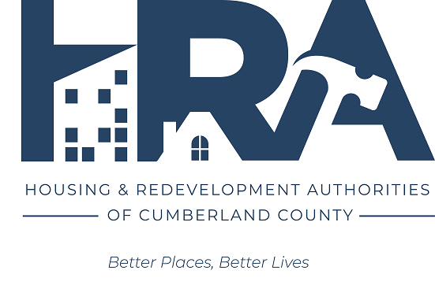


Cumberland County, Pennsylvania
CDBG & HOME Programs
PY 2026 Citizen Participation Report

Prepared by: The Redevelopment Authority of the
County of Cumberland

July 2026

Summary:
Cumberland County held two public hearings (June 11, 2026, and July 15, 2026) related to the PY 2026 AAP. The County Commissioners voted to approve the draft AAP proposal on 7/15/2026, following the second public hearing. The first and second public hearing, as well as the thirty-day public comment period (6/12/2026-7/12/2026), were advertised in the Sentinel, a newspaper of general circulation (See appendix). The public hearings and relevant AAP information were advertised and available for public review on www.cchra.com, at the Cumberland County Commissioners' Office in Carlisle, and at the eight Cumberland County libraries (Cleve J. Fredricksen Library in Camp Hill, Bosler Memorial Library in Carlisle, Amelia Givin Library in Mount Holly Springs, East Pennsboro Branch in Enola, John Graham Library in Newville, New Cumberland Library in New Cumberland, Simpson Library in Mechanicsburg and the Coy Public Library of Shippensburg). The public was invited to comment via U.S. Postal Mail, email, and telephone. The first public hearing was held virtually. The second public hearing and voting meeting were held in person and virtually.
The virtual and in-person public hearing and voting meeting were conducted before the Cumberland County Commissioners on July 15, 2026, at 1:30 p.m. during the Commissioners’ Meeting. The Commissioners voted to approve the draft PY 2026 AAP and submit it to HUD. The public was invited to attend the public hearing and board meeting either virtually via Zoom or in person in the Commissioners' Meeting Room at the Cumberland County Courthouse.
No public comments were received or made during the hearings.
Included in this report is evidence of advertisement of the hearings and of funding recommendations.

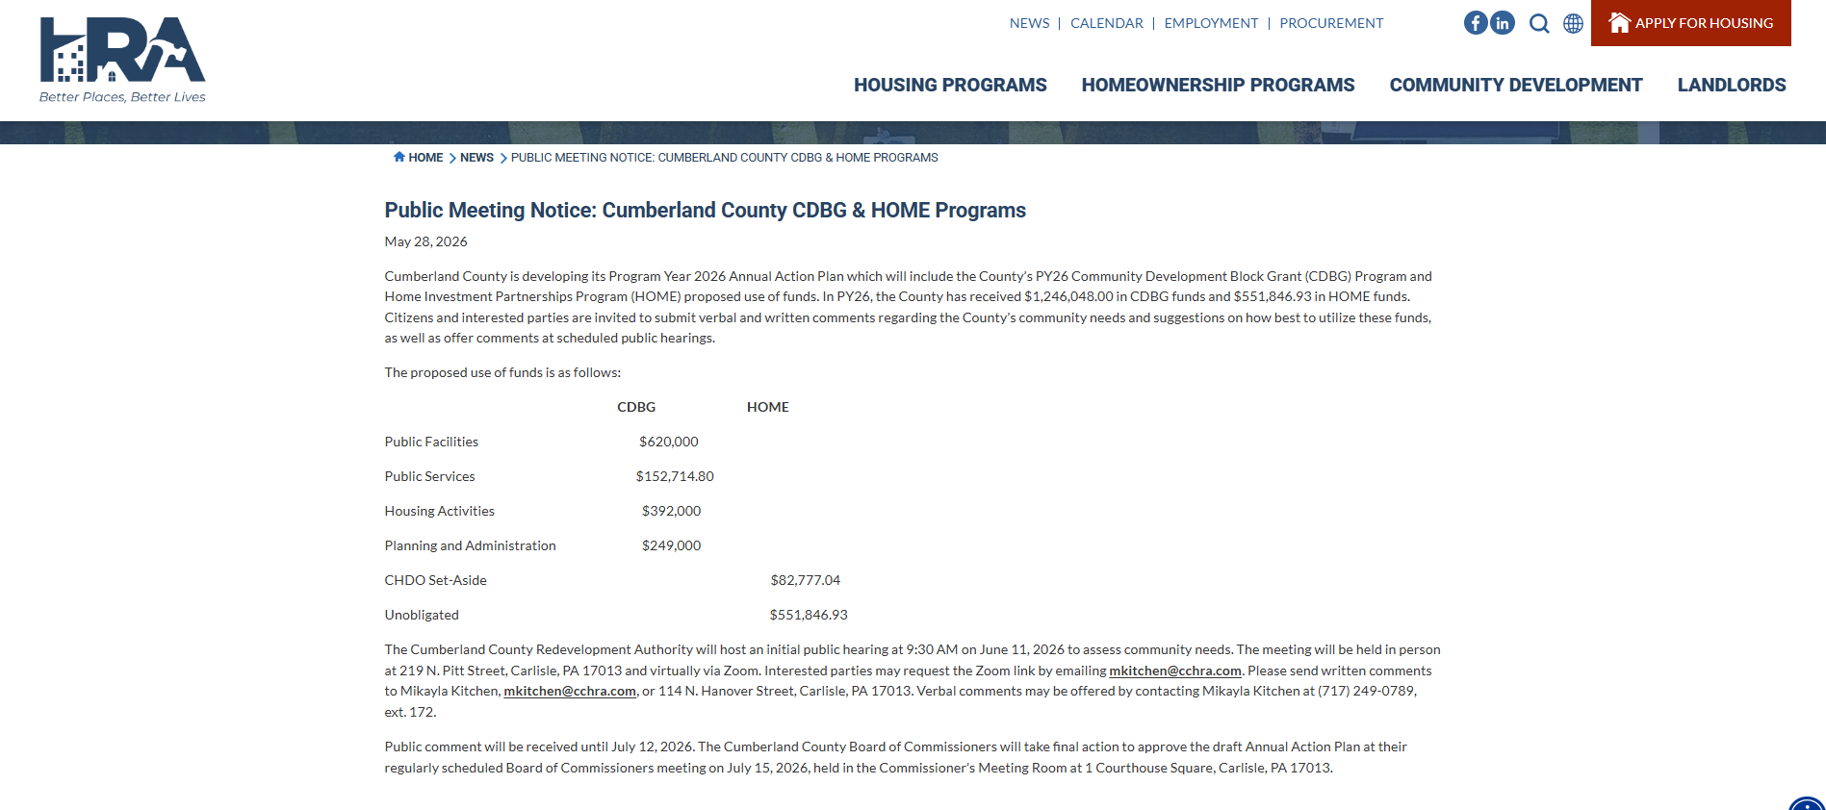
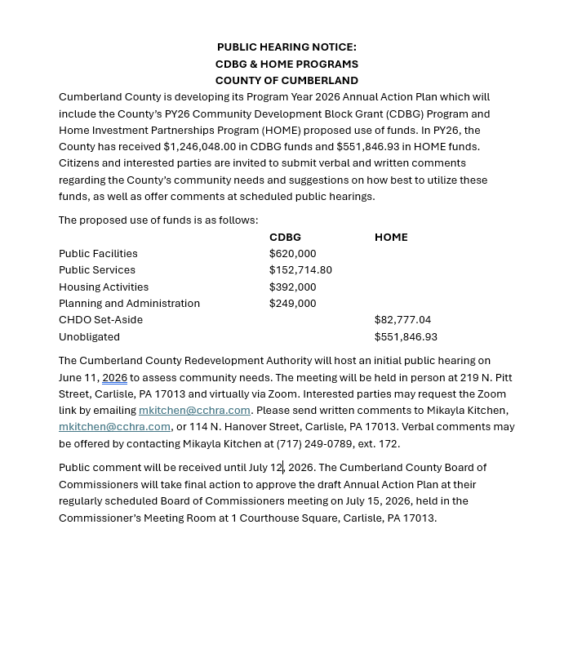
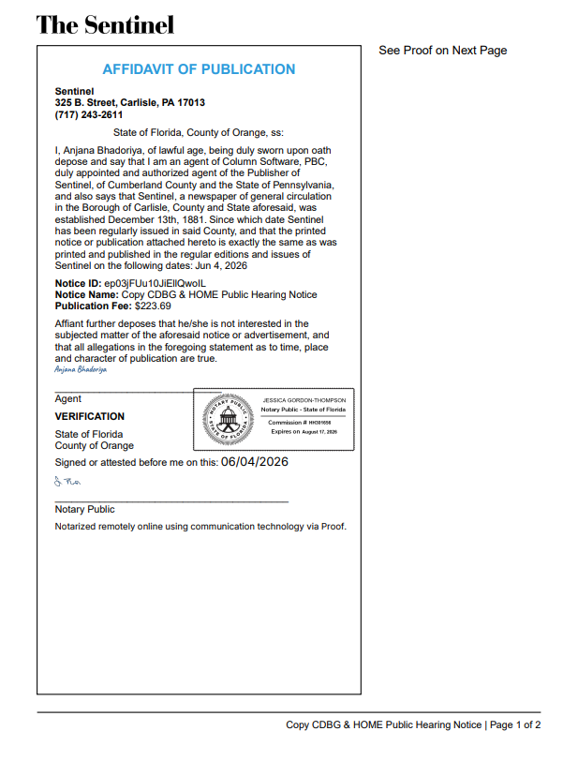
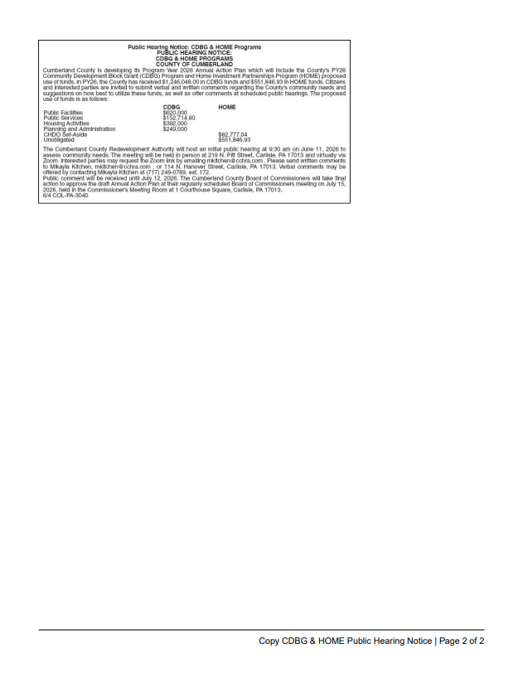

Grantee SF-424's and Certification(s)
